Integrated Paperless Document Tracking and Workflow System for DSWD Utilizing Support Vector Machine Classification

SVM-Based Document Classification Engine for Automated Workflow Tracking Systems
A Research Project
Presented to the Faculty of the
School of Computer Studies
Arellano University, Manila
By:
Gizzle Montemayor
Abner T. Duarte, Jr.
Ace Vergel S. Correa
Co-Author:
JONNIFER MANDIGMA
In Partial Fulfillment
of the Requirements for the Degree
Bachelor of Science in Computer Science

Date of Final Defense

TABLE OF CONTENTS
PRELIMINARIES
Title Page i
Approval Sheet ii
Acknowledgement iii
Abstract v
Table of Contents vii
List of Tables x
List of Figures xi
Chapter 1 - INTRODUCTION
Introduction 5
Background of the Study 6
Statement of the Problem 8
Objectives of the Study 9
Scope and Limitations of the Study 12
Significance of the Study 13
Chapter 2 - REVIEW OF RELATED STUDIES AND LITERATURE
Theoretical Background 16
Technical Background 18
Related Literatures, Studies and Systems 20
Developmental Tools 25
Evaluation System 28 Conceptual Model 32
Synthesis 33
Operational Definition of Terms 34
Chapter 3 - DESIGN AND METHODOLOGY
Project Design 36
Project Development 40
System Design and Development Model/Approach 49
Operation and Testing Procedure 53
Evaluation Procedure 57
Research Instruments Used 59
Population and Sample 62
Statistical Treatment of Data 62
Chapter 4 - RESULTS AND DISCUSSION
Project Description
Project Structure
Project Capabilities and Limitations
Project Testing
Project Evaluation
Chapter 5 - SUMMARY OF FINDINGS, CONCLUSIONS, AND RECOMMENDATIONS
Summary of Findings
Conclusions
Recommendations
References
Appendices
Appendix A - Testing Instrument
Appendix B - Evaluation Instrument
Appendix C - Testing Results per Criterion
Appendix D - Evaluation Results per Criterion
Appendix E - Summary of Testing by the User-respondents
Appendix F - Summary of Evaluation by the Evaluator-respondents
Appendix G - User's Manual
Appendix H - Transcripts of Interview / Observation (with photos)
Appendix I - Topical Outline
Appendix J - Interview Questionnaire
Researcher's Profile

Chapter 1

THE PROBLEM AND ITS BACKGROUND

Introduction

Efficiency, transparency, and flexibility have become the hallmarks of good governance in the modern era of public service delivery. For government agencies tasked with providing essential social services—especially those handling public assistance and disaster response—fast, uncomplicated administrative processes aren't just convenient; they're critical, since any delay can directly affect the well-being of the citizens who depend on them. Yet manual routing, localized filing systems, and stacks of physical paperwork still dominate day-to-day operations in much of the public sector. Beyond the high overhead costs these outdated methods carry, they're also prone to processing bottlenecks, human error, and physical wear and tear—all of which ultimately slow down the delivery of services citizens rely on.

The shift toward hybrid work arrangements worldwide has only made administrative modernization more urgent. For government agencies operating across central, regional, and satellite offices, keeping operations running smoothly when staff are split between on-site and remote setups is no small feat. Physical files, by their very nature, are tied to a single location—which makes traditional paper-based document tracking fundamentally at odds with hybrid work, and makes real-time collaboration and oversight nearly impossible.

To help close this gap, this study proposes the "Integrated Cloud-Enabled Paperless Document Tracking, Workflow Management, and Disaster Relief Distribution Reporting System". Moving from physical documents to a centralized, cloud-enabled infrastructure would let the target institution meaningfully cut its environmental footprint. More importantly, a digital workflow management system means tasks can be routed, reviewed, and approved instantly no matter where an employee happens to be working—removing the hassle of physical transmittals altogether.

The system also brings full administrative transparency to the table. Every action, change, and transition a document goes through leaves behind an unchangeable digital trail, making real-time monitoring and accountability possible. Ultimately, this research aims to equip the target government agency with a strong, scalable digital framework—one that keeps social services flowing promptly, transparently, and without interruption to the citizens who need them most, while also streamlining internal administrative efficiency.

Background of the Study

The Department of Social Welfare and Development (DSWD) is the government agency mandated to develop, implement, and coordinate social protection and welfare programs for the poorest, most vulnerable, and disadvantaged sectors of Philippine society. Set up to turn national social welfare policy into direct services at the community level, the DSWD runs a nationwide network of central, regional, and field offices that reach citizens even in the country's most remote areas—making it the frontline institution behind the country's social safety net.
.
On any given day, the DSWD handles an enormous volume of transactions—assessing and approving requests for public assistance, releasing emergency relief goods and cash aid to disaster-stricken families, and administering large-scale poverty-reduction programs such as the Pantawid Pamilyang Pilipino Program (4Ps), which alone serves millions of household-beneficiaries nationwide. Because these transactions translate directly into food, shelter, medical aid, and financial relief for citizens in crisis, how fast and accurately the DSWD's internal administrative machinery runs has a real, tangible impact on people's lives. In disaster situations especially, that speed can mean the difference between timely relief and prolonged hardship.

Despite this critical mandate, the DSWD's bureaucratic structure has traditionally leaned on paper-based document tracking. Memoranda, project proposals, financial disbursement vouchers, and assistance applications physically travel through central, regional, and local offices along a convoluted chain of command, often needing a wet signature at every stage before a request can move forward. Disaster relief distribution reporting feels this the most: when a typhoon, flood, or other calamity hits, field offices have to manually compile relief-goods inventories, beneficiary lists, and distribution logs on paper before consolidating them into reports for the national office—a process that ends up slowing down the very reporting meant to track how quickly aid reaches affected families. Paper documentation has long been the standard for audit trails and regulatory compliance, but it carries real drawbacks in the DSWD's current administrative environment:
- Geographic Barriers and Late Deliveries: Physical routing is a bottleneck by nature. Documents can sit on a desk waiting for a signature, or get held up in transit between offices—directly stalling the release of vital citizen services.
- The Hybrid Workplace Conflict: Hybrid work arrangements, where government personnel split their time between on-site duties and remote work, have exposed just how limited legacy systems really are. If a critical workflow depends on a physical piece of paper, everything stalls the moment a key decision-maker is working remotely or stationed at a different satellite office.
- Lack of Real-Time Visibility: For citizens and staff alike, tracking down the exact status of a pending request usually means digging through a manual logbook or making a follow-up phone call—creating an operational “black box” that gets in the way of administrative transparency.

Modernizing this workflow means turning to cloud technology—not as an innovative option for the DSWD, but as an operational necessity. A cloud-enabled system decentralizes data access, letting authorized personnel across the agency's central, regional, and field offices securely review, route, and approve documents, and consolidate disaster relief distribution reports, from anywhere, at any time. This shift also falls squarely in line with Republic Act No. 11032 (the Ease of Doing Business and Efficient Government Service Delivery Act), which requires agencies like the DSWD to reengineer their systems to cut red tape and speed up public transactions.

Given its role as the country's principal social welfare institution, how quickly the DSWD digitizes its document routing and disaster relief reporting matters well beyond internal efficiency—it shapes how fast the agency can respond when Filipino families need help most. It's within this context, centered squarely on the DSWD's own operations, that this study situates its investigation.

Statement of the Problem
The main problem dealt with the continued reliance of the Office of the Secretary of the Department of Social Welfare and Development on manual, paper-based methods in tracking official documents and monitoring disaster relief distribution, which results in delayed document processing, difficulty in locating and monitoring the status of documents, and the absence of a reliable and real-time way of recording and monitoring relief goods and their distribution to affected communities.
Specifically, the study sought to answer the following problems:
- Currently, administrative bottlenecks in the manual document tracking of the DSWD Office of the Secretary cause processing delays and file misplacement. This study identifies these operational issues to establish system requirements.
- Presently, workflow delays arise from manual categorization and physical document transfers. This study develops a paperless system integrating RBAC, QR code tracking, real-time dashboards, automated routing, and an SVM classification model.
- In the existing architecture, security vulnerabilities and data handling risks compromise official records during transfers. This study implements Role-Based Access Control (RBAC), document encryption, and tamper-proof audit logging to ensure data security, confidentiality, and record integrity across all system users.
- Under current practices, quality verification gaps limit the formal assessment of digital tools in evaluating overall platform quality using the ISO/IEC 25010 in terms of:
3.1 Functional Suitability;
3.2 Performance Efficiency;
3.3 Usability;
3.4 Reliability; and
3.5 Security?

Objectives of the Study
Broadly, this study aimed to develop, design, and implement a cloud-enabled paperless document tracking, workflow management system, and disaster relief distribution reporting module tailored specifically for the Department of Social Welfare and Development (DSWD), with the goal of optimizing administrative efficiency within a hybrid work environment. To get there, the study built a secure, role-based user management module that lets both remote and on-site DSWD personnel seamlessly access and collaborate on institutional workflows, closing the gap between office-based and remote operations. It also developed a dynamic workflow automation engine capable of routing administrative documents, tracking their status in real time, and generating an immutable digital audit trail—eliminating systemic bottlenecks and ensuring full operational transparency and accountability. On top of that, the study incorporated a disaster relief distribution reporting module to consolidate relief-goods encoding and reporting while significantly cutting the agency's reliance on physical paper and printing resources, in line with environmental sustainability goals and national ease-of-doing-business mandates. Finally, the resulting software platform was evaluated against the ISO/IEC 25010 standard to confirm its technical usability, security, and performance reliability within a government public service framework.
Specifically, it aims to:
- Design the software with the following features/modules:
- User Management & Role-Based Access Control (RBAC) Module: Manages user authentication and restricts system access according to assigned roles to protect sensitive data.
- SVM Document Classification Module: Extracts text features using TF-IDF and uses a Support Vector Machine (SVM) model to automatically categorize incoming administrative files for faster processing.
- Automated Workflow & Routing Engine: Automatically forwards classified documents along official office approval paths, handling multi-stage sequential or parallel reviews without manual hand-to-hand transfers.
- Scannable QR Code & Retrieval Module: Generates unique QR codes embedded into official documents and manifests to allow rapid status lookup, verification, and physical-to-digital document tracking.
- Real-Time Tracking Dashboard & Analytics: Displays live status updates, processing turnaround times, active bottlenecks, and workflow logs across departments for administrative oversight.
- Disaster Relief Distribution & Reporting Module: Tracks disaster relief inventories, records goods allocations, links distribution manifests to official approval workflows, and automatically generates relief summary reports.
- Security, Encryption & Audit Trail Module: Applies document encryption protocols and maintains an immutable, tamper-proof history log that permanently records every action, approval step, and timestamp for full accountability.

- Create the software application using PHP for backend logic, MySQL for database management, and HTML5/CSS3/JavaScript for a responsive user interface, ensuring seamless integration of all property management modules.
- To evaluate and iteratively optimize the Support Vector Machine (SVM) classification algorithm using text feature vectors (TF-IDF), measuring its predictive performance in terms of Accuracy, Precision, Recall, and F-score to ensure reliable and automated document categorization.
- Evaluate the system’s performance and quality based on the ISO/IEC 25010 standard, focusing on its Functional Suitability, Performance Efficiency, Compatibility, Usability, Reliability, Security, Maintainability, Portability through structured user-respondent testing.

Scope and Limitations of the Study

This study covers the design, creation, testing, improvement, and evaluation of the cloud-enabled paperless document tracking and workflow management system with disaster relief distribution reporting, built specifically around the operational dynamics of the Department of Social Welfare and Development (DSWD). Its focus stays on secure and efficient workflows, anchored by a robust Role-Based Access Control (RBAC) mechanism that lets DSWD employees—whether on-site or remote, and regardless of whether they're encoders, reviewers, approvers, or high-level administrators—operate with permissions tailored to their role. Rounding it out, a centralized dashboard offers real-time tracking and a comprehensive audit trail, giving full visibility into a document's current station, the time it's spent at each office, and an immutable history log of every modification and approval to keep transparency intact.

The study was conducted within School Year 2026, and its intended users were the Administrators, Department Users, and Logistics/Relief Officers of the Office of the Secretary, who were responsible for testing and evaluating the system's features. The system covered the encoding, routing, and monitoring of official documents; the recording and monitoring of relief inventory and distribution; and the generation of relief manifests for official routing and approval, all accessible through a single, role-based platform.

Beyond these intentional boundaries, the study also faces a few inherent limitations outside the researchers' control. The platform's overall uptime and security depend heavily on the stability of the third-party cloud service provider's infrastructure, and its day-to-day performance hinges entirely on the user's internet connectivity—leaving it vulnerable to latency issues in low-bandwidth or remote satellite areas. System adoption may also be slower in practice due to varying levels of digital literacy and some cultural resistance to change among traditional bureaucratic personnel. The study also did not cover the physical printing, packing, or delivery of relief goods to evacuation centers, as these remain the responsibility of the department's existing logistics personnel; the system was limited to the electronic recording, monitoring, and reporting of these activities. Furthermore, the barcode feature of the system was limited to generating and reading barcodes for document identification and retrieval only, and did not extend to the tracking of individual relief goods through barcode or similar means.

Significance of the Study

This study centers on the design, creation, testing, improvement, and evaluation of a cloud-enabled paperless document tracking and workflow management system with disaster relief distribution reporting. A number of stakeholders stand to benefit significantly, as the study promotes more responsive, transparent, and environmentally friendly government operations. It will be of particular value to the following:

The Office of the Secretary and Administrators: This study gives leadership a clear overview of organizational workflows. With access to real-time analytics and tracking, administrators can quickly spot systemic bottlenecks, objectively monitor employee performance, and make data-driven decisions to optimize workforce allocation in hybrid settings.

The employees of the Office of the Secretary (On-site and Remote): The administrators, department users, and logistics/relief officers who operate the system on a daily basis will directly benefit from a platform that reduces the time and effort spent on manually routing documents and recording relief distributions, allowing them to accomplish their tasks more efficiently and with greater accountability.

The disaster-affected communities: As the ultimate beneficiaries of the system's purpose, the families and evacuation centers that receive disaster relief will benefit the most in real terms, since a more accurate and better-monitored distribution process helps ensure that relief goods reach them quickly, fairly, and without unnecessary delay.

The Department of Social Welfare and Development. Once proven effective at the Office of the Secretary, the system is intended to be deployed to DSWD's other offices and field offices nationwide, allowing the department as a whole to benefit from a more organized and accountable way of managing its documents and relief operations.

The students, the faculty, and future researchers. While these groups are not direct users of the system, they stand to benefit from this study as an academic reference, whether in understanding how a computerized system is applied to real government operations, in using this study as a discussion material in relevant subjects, or in building on this research for related studies in the future.

Chapter 2

REVIEW OF RELATED LITERATURE AND STUDIES
This chapter presents the existing literature and other publicly available information that supports the need for this research study. Conceptual and research literature is presented, which serves as references and sources of insights for the researcher. It also includes conceptual models or frameworks in order to establish the probable solution to the research problem. In addition, a synthesis is also presented to summarize, give analysis, and conclude on the literature and studies presented.

Theoretical Background
This study is guided by the concept of workflow management, which refers to the coordination of tasks, information, and people involved in completing a particular process from start to finish. In the context of this study, workflow management is applied through the idea of a finite state machine (FSM), a concept used to describe a process that moves through a limited and clearly defined set of stages, where a task can only move from one stage to another based on a specific action taken by a user. This concept directly supports the research problem of this study, since it explains how a document's progress, from the moment it is created up to the moment it is marked complete, can be represented as a series of defined stages such as Draft, Pending Routing, In Transit, Received, and Completed, allowing its exact status to be identified and monitored at any given time.

This study is also guided by the concept of relational database management, which refers to the organization of data into related tables that are connected to one another through common fields, allowing information to be stored accurately while avoiding unnecessary repetition. Alongside this, the study makes use of the concept of Atomicity, Consistency, Isolation, and Durability, commonly referred to as ACID properties, which describe the conditions that must be met for a series of related database operations to be considered complete and reliable. These concepts connect directly to the objectives of this study, since they explain how the system is able to maintain accurate and consistent records of both documents and relief inventory, particularly in ensuring that relief goods are not mistakenly distributed in excess of what is actually available.

The Technology Acceptance Model (TAM), developed by Fred Davis in 1989, complements this operational focus by offering a framework for understanding and predicting how users will adopt the new digital platform. TAM holds that two cognitive factors mainly drive a user's acceptance of a technology: perceived usefulness—the belief that the system will improve job performance—and perceived ease of use, the belief that using it will take little effort. Because moving the DSWD from long-standing manual paperwork to a cloud platform could create friction among staff with different levels of digital literacy, TAM directly informs the system's user experience design. This keeps the platform accessible and intuitive, which lines up directly with the usability standards assessed later in the ISO/IEC 25010 software evaluation.

Technical Background
The development of this study made use of several tools, platforms, and programming languages suited for building a web-based information system. The system's back-end was developed using PHP, an object-oriented, server-side scripting language, together with MySQL as its relational database management system (RDBMS) for storing and managing document and relief distribution records. Bootstrap was used to design a responsive and modern front-end interface, while JavaScript, together with the Asynchronous JavaScript and XML (AJAX) technique, was used to allow the system to process actions such as saving, routing, and searching for documents without requiring the page to reload. Supplementary libraries were also incorporated into the system, including Data Tables for organizing and searching through large sets of records, SweetAlert2 for displaying user notifications, Chart.js for visualizing relief distribution trends, and a barcode generation and scanning library for producing and reading document barcodes through a device camera. The system was developed and tested using Laragon, a local development environment that allowed the researchers to simulate a live server environment composed of Apache and MySQL prior to actual deployment.
Similar problems in the past have been addressed through simpler, standalone approaches, such as spreadsheet-based logs for document tracking or manual inventory sheets for relief distribution, neither of which offered real-time monitoring, routing, or an integrated view of both concerns at once. Some organizations have also adopted barcode-based inventory systems solely for tracking physical goods, without extending this capability to official document management, which is one of the gaps that this study intends to address by combining both functions into a single platform. In developing and testing the system, the researchers anticipated certain technical difficulties, particularly those related to browser and device compatibility, since the barcode scanning feature depends on a device's camera and on browser support for barcode detection, which may not function consistently across all browsers or older devices. Compatibility concerns were also expected in relation to the database management system, as differences between MySQL versions can affect default authentication methods and require manual configuration before a connection can be established. These anticipated difficulties were considered during development in order to ensure that the system remains functional and reliable despite variations in the hardware and software environment in which it may be deployed.
A secure authentication layer to manage Role-Based Access Control (RBAC), and an asynchronous queueing infrastructure that offloads data-heavy processes—like automated PDF generation and notification dispatches—without slowing down user response times.

Data persistence and relational integrity are maintained through a centralized MySQL or PostgreSQL database management system. Acting as the system's ledger, this relational backend houses normalized tables for user credentials, permission matrices, office routing protocols, and document metadata. Actual file uploads—digital administrative attachments, text records, PDF documents—are kept separate from the main relational database and offloaded onto high-availability cloud object storage, such as Google Cloud Storage or Amazon S3, to avoid bogging down database performance. To keep query speeds fast and maintain data redundancy, the relational database stores only the files' cryptographic hashes and secure, encrypted URLs.

Related Literature, Studies and Systems

Major Topic: Document Tracking System
According to Jaquilmo and Sarmiento (2023), a document tracking system refers to the professional practice of managing an organization's documents, covering the identification, classification, storage, security, retrieval, tracking, and preservation of records as they move within and between offices. Their study noted that many government offices, particularly the Department of Social Welfare and Development Field Office V, still relied on manual encoding through logbooks to track official documents, a practice that made locating files difficult, wasted time in archiving and searching, and sometimes resulted in documents being permanently lost. This observation supports the general problem addressed by the present study, in which similar manual practices at the Office of the Secretary create comparable delays and difficulties in monitoring document status.
To address this problem, Jaquilmo and Sarmiento (2023) developed a Web-Based Electronic Document Tracking Management System equipped with a barcode scanner, email, and SMS support, allowing documents to be created, routed, and tracked electronically among different offices within a region. Their system was evaluated by information technology experts and actual office users based on its functionality, reliability, usability, efficiency, maintainability, and portability, obtaining an overall mean rating of 4.257, which was interpreted as exceeding what was expected of the system. This finding demonstrates that a computerized, barcode-supported document tracking system is both a feasible and effective replacement for a manual, logbook-based process, supporting the direction taken by the present study in developing a similar system for the Office of the Secretary.

Subtopic A: Disaster Relief Distribution Monitoring
In the study conducted by Rodriguez, Serrano, and Balan (2017), it was found that local government units in the Philippines commonly lacked a proper database or system for monitoring relief goods and donations during disaster response, based on assessment findings by the Commission on Audit. The same study reported that lapses in the documentation and recording of donated relief goods and supplies made it difficult to determine an accurate inventory of relief items, which in turn affected the ability of decision-makers to plan and distribute assistance appropriately during a calamity. To address this gap, the researchers developed Anduyog, a web-based application capable of monitoring relief distribution, casualty information, and inventory for local government units, which was evaluated positively by barangay, municipal, and provincial-level users across several usability measures, including learnability, efficiency, error handling, and overall satisfaction.
As a result, based on the barcode and Quick Response (QR) code technology used in a study conducted by Piloton, Gamboa, Dela Cerna, and Reyna (2023), it was found that replacing a manual, handwritten logbook with a QR code-based records tracking system allowed a university office to record, transmit, and retrieve documents more efficiently, with the resulting system meeting the ISO 25010 software product quality standards during evaluation. This finding further supports the inclusion of a barcode-based feature in the present study's system, since it demonstrates that scannable codes are an effective and already-proven method of speeding up document identification and retrieval when replacing a manual, paper-based tracking process.
References (add to Chapter 2's reference list)
Jaquilmo, C. A., & Sarmiento, J. R. (2023). Web-based electronic document tracking management system. Global Scientific Journal, 11(5), 1108–1119.
Piloton, A. J., Jr., Gamboa, G. Z., Jr., Dela Cerna, M. A., & Reyna, R. A. (2023). Development of records tracking management system with QR code. International Journal for Multidisciplinary Research (IJFMR), 5(4).
Rodriguez, R. L., Serrano, E. A., & Balan, A. K. D. (2017). Anduyog: A web-based application for relief and casualty monitoring and early warning system for local government units in the Philippines. In 2017 IEEE Region 10 Symposium (TENSYMP) (pp. 1–5). IEEE. https://doi.org/10.1109/TENCONSpring.2017.8070002

Development Tools

- Visual Studio Code
Visual Studio Code served as the central workstation where all the programming for the system was written, tested, and managed. Rather than relying on a basic text editor, VS Code offers syntax highlighting, automatic code completion, and error detection that speed up development considerably. It also let the developers manage both the frontend (HTML/CSS) and backend (PHP) in one unified window, and it integrates smoothly with version control systems like Git to track code changes throughout the rapid development of the document routing modules.

- PHP (Hypertext Preprocessor)
PHP, short for Hypertext Preprocessor, is a widely used, open-source, server-side scripting language designed primarily for building dynamic and interactive web applications. It was chosen as the primary programming language for this study because of its strong support for object-oriented programming, its compatibility with the MySQL database management system, and its wide adoption in developing government and enterprise web-based systems similar to the one proposed in this study.
- Workflow Logic: When a DSWD hybrid worker uploads a document or clicks “Approve,” PHP captures that action, processes the logic behind it, and routes the document to the next person in line.
- Database Communication: PHP acts as the bridge between the website and the database, running the SQL queries that securely save document statuses, fetch user profiles, and record the exact timestamps behind the digital audit trails.
- Security & Sessions: PHP handles user authentication—when a remote worker logs in, PHP verifies their credentials and manages their “session,” making sure only authorized personnel can access sensitive government files.

- HTML
The Frontend Architecture / User Interface (UI). HTML builds the structure of the system, creating the digital forms used to upload files, the tables that display routing history, and the navigation menus.

- CSS
The Frontend Architecture / User Interface (UI). CSS handles the visual styling and layout. Since this system is built for a hybrid work environment, employees will access it from office desktops, home laptops, or even tablets—so CSS makes the system “responsive,” meaning the tracking dashboard automatically resizes and adjusts to look professional and function well on any screen size.

- Laragon
Local Web Server and Database Environment. Before a system goes live on a government cloud server, it needs to be built and tested locally, and Laragon provides a complete “server-in-a-box” environment for exactly that.
- Apache (The Web Server): This lets a local computer process PHP code and display the system in a web browser, just like a live website.
- MySQL / MariaDB (The Database): This is where the system's data actually lives. Laragon hosts the database tables that store all user accounts, document metadata, and workflow audit logs, allowing the entire document tracking process—from upload to final approval—to be tested safely without needing an internet connection or a paid server during development. It was selected as the database management system of this study because of its reliability, its native support for transactions that ensure data remains accurate even when multiple operations occur at the same time, and its seamless integration with PHP through the PHP Data Objects (PDO) extension.

- Bootstrap
Bootstrap is an open-source front-end framework that provides pre-designed components and a responsive grid system, allowing a website to automatically adjust its layout depending on the size of the screen it is viewed on. It was used in this study to design a modern, professional, and mobile-friendly interface without requiring the researchers to build every visual component from scratch.

- JavaScript and AJAX. JavaScript
A client-side scripting language that allows a webpage to respond to user actions without requiring the entire page to reload, while Asynchronous JavaScript and XML (AJAX) is a technique that allows a webpage to send and receive data from the server in the background. Both were used in this study to allow actions such as saving a document, routing it to another user, or recording a relief distribution to be processed instantly, providing a smoother and more responsive experience for the system's users.

ISO/IEC 25010
The International Organization for Standardization (ISO) and the International Electrotechnical Commission (IEC) developed the widely used ISO/IEC 25010 System and Software Quality Model to regulate and assess the overall quality of software products. The framework is built around eight quality characteristics—Functional Suitability, Performance Efficiency, Compatibility, Usability, Reliability, Security, Maintainability, and Portability—each broken down into specific sub-characteristics. Replacing the earlier ISO/IEC 9126 standard, it offers a structured, objective model that gives software developers, quality assurance experts, and institutional stakeholders a rigorous, unbiased way to assess how well an application meets both explicit functional requirements and implicit user expectations, making it one of the standard benchmarks for software engineering research today.

The following are the criteria set for ISO/IEC 25010:
- Functional Suitability. Through three sub-characteristics, Functional Suitability evaluates how well the developed platform meets the DSWD's operational mandates and document routing requirements. Functional Completeness assesses how well the implemented feature set—tracking dashboards, Role-Based Access Control (RBAC), and the workflow engine—covers all the administrative duties and document-handling procedures laid out in the study's objectives. And Functional Appropriateness assesses whether the application supports only the essential operational steps, cutting procedural bloat so DSWD staff can complete document transmittals with as few actions as possible. Based on the developed system, functional suitability is addressed through its ability to correctly create, edit, route, and archive documents; generate and scan barcodes for quick document retrieval; record relief inventory and automatically deduct distributed goods from available stock; and generate relief manifests that are routed through the same workflow as any other document.
- Performance Efficiency. This refers to the degree to which the system makes appropriate use of resources, such as processing time, while performing its intended functions. Based on the developed system, performance efficiency is addressed through the use of AJAX, which allows actions such as saving or routing a document to be processed without reloading the entire page, and through the use of indexed database queries, which allow a document to be located instantly when its exact tracking number is scanned or searched.
- Compatibility. This refers to the degree to which the system is able to exchange information with other systems and to function correctly while sharing a common hardware or software environment. Based on the developed system, compatibility is addressed through its use of standard web technologies that allow it to run on commonly used browsers and devices, while its camera-based barcode scanning feature is optimized to perform best on Chromium-based browsers such as Google Chrome and Microsoft Edge.
- Usability. This refers to the degree to which the system can be used by its intended users to achieve their goals effectively, efficiently, and with satisfaction. Based on the developed system, usability is addressed through a clean, role-based dashboard for each type of user, a responsive interface built with Bootstrap that adjusts to different screen sizes, toast notifications that confirm whether an action succeeded or failed, and a barcode scanning feature that allows a document to be located without manually searching through a list.
- Reliability. This refers to the degree to which the system performs its intended functions consistently and without failure under normal conditions of use. Based on the developed system, reliability is addressed through the use of database transactions that ensure a relief distribution and its corresponding inventory deduction are always recorded together, through pessimistic row-locking that prevents relief stock from being oversold when two users record distributions at the same time, and through a complete audit trail that logs every action taken on a document so that no step in its history is lost.
- Security. This refers to the degree to which the system protects information and data from unauthorized access, modification, or disclosure. Based on the developed system, security is addressed through password hashing that ensures passwords are never stored in plain text, protection against Cross-Site Request Forgery (CSRF) on every action that changes data, the use of prepared statements to prevent SQL injection, role-based access control that limits certain features to Administrators and Logistics/Relief Officers, and strict validation of uploaded files to ensure only legitimate PDF or Word documents can be attached to a record.
- Maintainability. This refers to the degree to which the system can be modified, corrected, or improved by its developers or administrators. Based on the developed system, maintainability is addressed through its object-oriented design, which organizes the system's logic into separate, well-defined classes for documents, relief operations, users, and file uploads, allowing a specific feature to be corrected or improved without affecting unrelated parts of the system.
- Portability. This refers to the degree to which the system can be transferred from one environment to another. Based on the developed system, portability is addressed through its use of widely supported technologies such as PHP and MySQL, which allow it to be deployed to different servers with minimal adjustment, supporting its intended rollout from the pilot office to DSWD's other offices and field offices nationwide.

Conceptual Model
Building on the concepts, theories, and findings drawn from related literature and studies, a conceptual model was developed to guide the conduct of this study.
INPUT PROCESS OUTPUT
Figure 1. The Conceptual Model of the Study

Knowledge Requirements
Human Resources
System Administrator
Department Staff
Approving Officers
End Users

Others
Manual Process Study
Workflow / FSM Theory
RDBMS / ACID Concepts
ISO/IEC 2510

Software Requirements
Visual Studio Code
HTML/CSS
PHP, MySQL, Bootstrap
JavaScript / AJAX
Laragon

Hardware Requirements
Desktop / Laptop
Internet Connection
QR / Document Printer
Mobile Device
System/Project Design
Database Schema
User Interface
Routing Workflow

System/Project Development
System Design
Database Design
User Interface Design
System Development
Integration of Cloud Storage
QR Code Generation

System/Project Testing
Functional Testing
User Acceptance Testing (UAT)
A new technology or an innovation
Integrated Cloud-Enabled Paperless Document Tracking, Workflow Management and Disaster Relief Distribution Reporting System.
EVALUATION
Evaluated using ISO/IEC 25010 (8 Characteristics)
Figure 1 illustrates the study's conceptual model through an Input-Process-Output (IPO) framework combined with an evaluation phase. The Input block covers the baseline needs—human resources, knowledge, software (Visual Studio Code, PHP(MySQL, Bootstrap), HTML/CSS, JavaScript/AJAX, Laragon), and hardware requirements. The Process block outlines the system's execution lifecycle: project design (gathering and analysis), project development (system, database, and user interface design alongside cloud storage integration and QR code generation), and rigorous testing (functional testing and user acceptance testing). The Output block represents the final deliverable—the Integrated Cloud-Enabled Paperless Document Tracking, Workflow Management and Disaster Relief Distribution Report System—which then goes through the final Evaluation phase.

Synthesis

This study focuses on developing, deploying, and evaluating an integrated, cloud-enabled system built to transition paper-heavy government workflows into an efficient digital space. Guided by an extended Input-Process-Output (IPO) framework, the project outlines core foundational inputs—from human roles like system admins and approving officers to hardware setup and a modern software stack featuring PHP (MySQL, Bootstrap), JavaScript/AJAX, Laragon, and Visual Studio Code. These elements drove a structured software development lifecycle, steering the team through thorough requirements gathering, database architecture, cloud and QR code integration for live tracking, and complete validation via functional testing and User Acceptance Testing (UAT).

Operational Definition of Terms
This section briefly defines each term based on how it is functionally used, specifically describing how it applies within this study.
Integrated Cloud-Enabled Paperless Document Tracking, Workflow Management, and Disaster Relief Distribution Reporting System – Refers to the specific software output developed in this study using Visual Studio Code, PHP(MySQL, Bootstrap), HTML/CSS, JavaScript/AJAX, and Laragon. It functions as the central platform to digitize, monitor, and route organizational documents without physical paper, utilizing cloud storage and QR code tracking.
Input – Represents the foundational baseline requirements gathered at the start of the study, which include human resources (administrators, staff, approving officers, and end users); hardware (laptops, printers, and mobile devices); and software tools needed to initiate the project.

Process – Refers to the systematic systems development lifecycle (SDLC) phases executed in this study, which encompass requirement gathering, system analysis, database and user interface design, cloud and QR integration, and system testing.

Output – The tangible, completed technological innovation resulting from the development process—specifically, the operational document tracking system ready for deployment.

Evaluation – The final phase of the study where the developed system is assessed for its efficiency, usability, and technical performance, ensuring it meets the project's goals and user requirements.

QR Code Generation – The specific technical process integrated during development to create unique, scannable quick-response codes that are attached to documents to facilitate real-time tracking via mobile devices or scanners.

User Acceptance Testing (UAT) – The final testing phase where actual end users (Department Staff, Approving Officers, etc.) interact with the system to validate its features, usability, and readiness for official implementation.

Chapter 3
DESIGN AND METHODOLOGY
This chapter presents the project design, project development, systems development model, methods and instruments used in testing and evaluating the software, population and sample, as well as the statistical treatment of data.

Project Design

This study used both descriptive and developmental research methods. The descriptive method was used to systematically collect, analyze, and document the current workflow challenges, knowledge requirements, and technical needs of the stakeholders, while the developmental method guided the design, construction, testing, and evaluation of the technical solution itself—specifically, a structured software development lifecycle that translated these requirements into the functional Cloud-Enabled Paperless Document Tracking and Workflow Management System.
The descriptive method, specifically, was used to compile, evaluate, and record the institution's technical system requirements, stakeholder workflows, and manual document tracking procedures.
The researchers then applied the developmental method to design, build, test, and refine the software architecture, ultimately producing a working Cloud-Enabled Paperless Document Tracking and Workflow Management System based on the requirements gathered.

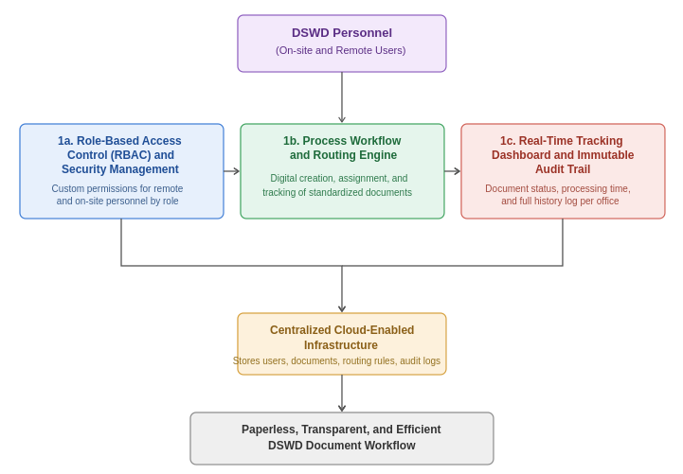

Figure 2. The Block Diagram/Framework of the Study
Figure 2 shows the architecture and operational flow of the proposed document system built for DSWD staff. System users—both on-site and remote DSWD personnel—are the first to engage with three interconnected software modules: (1a) Security Management and Role-Based Access Control (RBAC), which enforces role-specific permissions; (1b) the Dynamic Workflow Automation and Routing Engine, which manages standardized document creation, assignment, and routing; and (1c) the Immutable Audit Trail and Real-Time Tracking Dashboard, which keeps a secure record of document status, processing times, and historical logs across offices. Together, these modules feed into a centralized, cloud-enabled infrastructure that safely hosts and processes users, documents, routing rules, and audit logs, continuously syncing across the system. The end result is a paperless, transparent, and efficient document workflow for the DSWD.

Encoder
System Administrator
Reviewer / Approver
DSWD Management
Document Tracking and Workflow System
Document Upload
Routed docs, notifications
Tracking and relief reports
Account and role setup
Figure 3. The Context Diagram of the System
Figure 3 illustrates the Document Tracking and Workflow System's context diagram and user interaction model, mapping the data inputs and outputs handled by different stakeholders. The process flow shows the system administrator supplying the inputs needed for account and role setup, while the encoder feeds data into the central system through document uploads. In turn, the system produces outputs for authorization and supervision—sending notifications and routed documents directly to the reviewer or approver, and giving DSWD management thorough tracking and relief reports.
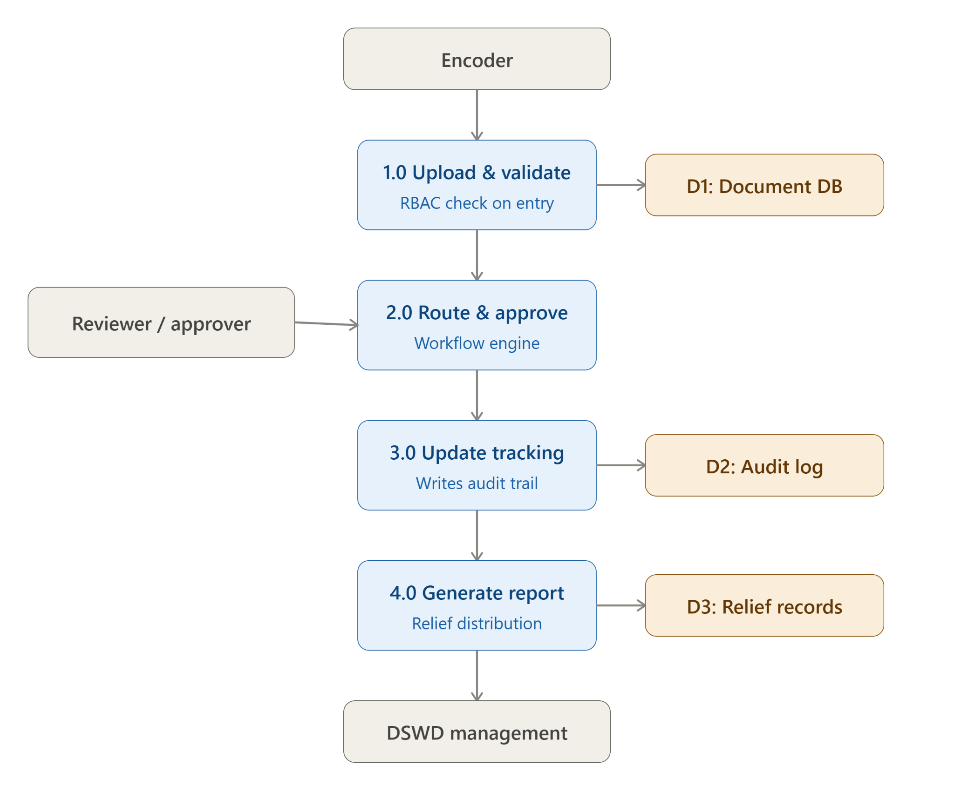

Figure 4. The Dataflow Diagram of the System
Figure 4 shows a Level-0 data flow diagram that follows a document from the encoder through four numbered processes—upload/validate, route/approve, update tracking, and generate relief report—each reading from or writing to its own data store before the relief distribution report reaches DSWD management.

Project Development
Five main components were designed, coded, and integrated to build the Cloud-Enabled Paperless Document Tracking and Workflow Management with Disaster Relief Distribution Reporting System: the User Login and RBAC Module, the Workflow Automation and Routing Engine, the Real-Time Tracking Dashboard and Audit Trail, the QR Code Generation and Scanning Module, and the Disaster Relief Distribution Reporting Module. Since every subsequent action in the system needed to be tied to an authenticated, role-verified user, the components were developed sequentially, with earlier modules like RBAC serving as a dependency for the ones built afterward.
- Gathering and analyzing requirements by directly observing the DSWD's current manual document-routing procedure and interviewing encoders, reviewers, and approving officers.
- Designing the database, including normalized tables for document records, workflow status, audit logs, disaster relief distribution records, and user accounts and roles.
- Designing and laying out the login screen, dashboards, and forms for every user role using HTML and CSS.
- Building the PHP Login and RBAC module, which limits each screen and action to the permissions assigned to administrators, encoders, reviewers, and approvers.
- Building the Workflow Automation and Routing Engine, which enables documents to be created, assigned, and forwarded according to the office hierarchy, either sequentially or concurrently.
- 6. Building the Real-Time Tracking Dashboard and Audit Trail, which shows authorized users the current document status and logs every status change and action in an unchangeable record.
- Building the QR code generation and scanning functionality, giving each document or relief record a unique, scannable code for quick access.
- Building the Disaster Relief Distribution Reporting module, which enables relief data to be encoded and compiled into reports.
- Once all modules were integrated into a single functional system, the proponents conducted internal testing to catch any flaws before turning it over for user testing.
- 10. Before the user acceptance testing and evaluation phase, covered later in this chapter, the system was deployed on Laragon for local testing.

In developing the Integrated Cloud-Enabled Paperless Document Tracking, Workflow Management and Disaster Relief Distribution Reporting System, the researchers undertook the following steps:
- Requirements Gathering and Analysis
- Database Design
- User Interface Design and Layout
- Development of the Login and RBAC Module
- Development of the Workflow Automation and Routing Engine
- Development of the Real-Time Tracking Dashboard and Audit Trail
- Development of the QR Code Generation and Scanning Module
- Development of the Disaster Relief Distribution Reporting Module
- Integration and Proponent Testing
- Deployment for User Acceptance Testing
Requirements Gathering and Analysis. To document the agency's current manual routing process, its pain points, and the specific data each office needed to collect, the researchers observed and interviewed DSWD encoders, reviewers, and approving officers.

Database Design. Using the requirements they'd gathered, the researchers created normalized database tables for user accounts and roles, document records, workflow status, audit logs, and disaster relief distribution records—ensuring every piece of data had one single, reliable source of truth.

User Interface Design and Layout. The login screen, role-specific dashboards, and document/relief-entry forms were laid out using HTML and CSS, with an emphasis on responsive design that works well on tablets, home laptops, and office desktops alike.

Development of the Login and RBAC Module. This module was developed first since every other module depends on it—it authenticates users in PHP and limits each screen and action to the permissions assigned to Encoders, Reviewers, Approvers, or Administrators.

Development of the Workflow Automation and Routing Engine. This module replaces the manual routing slip, enabling a document to be created, assigned, and forwarded according to the DSWD's office hierarchy, either sequentially or concurrently.

Development of the Real-Time Tracking Dashboard and Audit Trail. This module shows authorized users the current document status regardless of where they're physically located, and logs every status change and user action in an unchangeable record.

Development of the QR Code Generation and Scanning Module. Each document or relief record is given a unique, scannable QR code, enabling quick lookup and status verification through a mobile device or scanner.

Development of the Disaster Relief Distribution Reporting Module. This module makes it possible, during a disaster response, to encode relief distribution data and compile it into reports for DSWD management.

Functional Testing. Before external testing began, the proponents integrated all the modules into a single functional system and tested it internally to catch any flaws.
Deployment for User Acceptance Testing. To prepare for the User Acceptance Testing and evaluation phase covered later in this chapter, the integrated system was set up on Laragon for local testing.
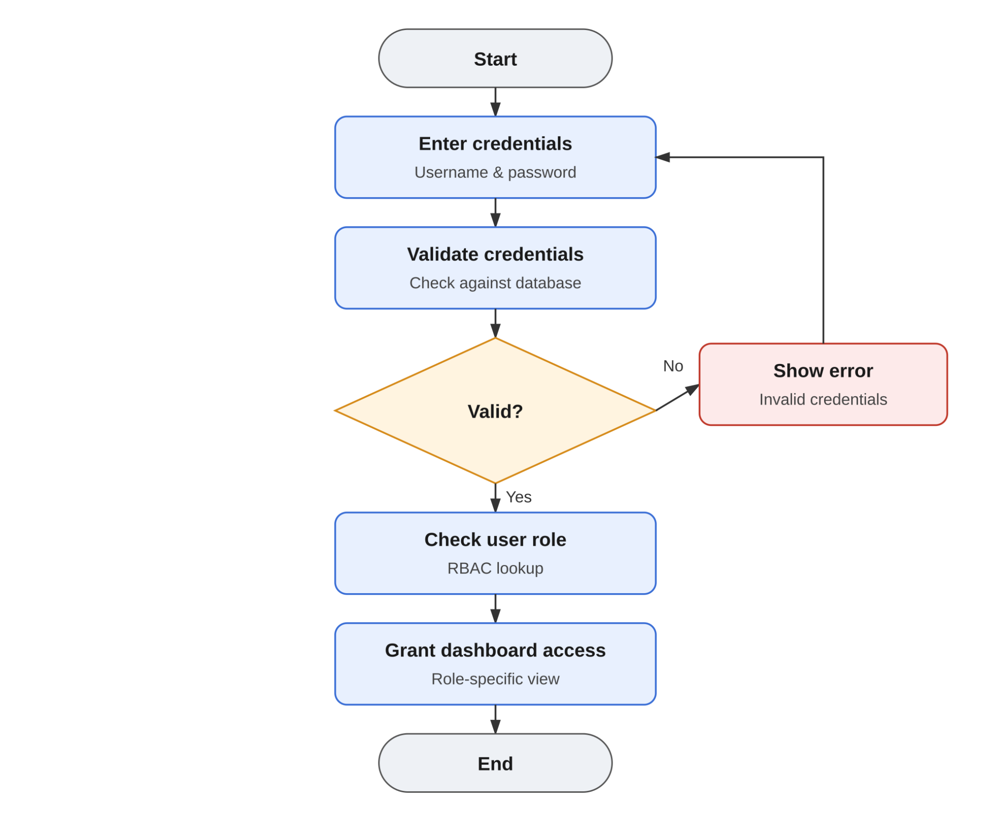
Figure 5. Program Flowchart of Feature #1
Figure 5 illustrates the system's user authentication and role-based access control (RBAC) flowchart, outlining the logical steps needed to protect dashboard access. The process starts at the Start node, where the user enters a username and password. The system then verifies those credentials against the database. A decision point checks whether the input is valid: if not, the user loops back to the input step and sees an error for invalid credentials; if valid, the system performs an RBAC lookup to check the user's role, which ultimately determines whether dashboard access is granted with a role-specific view, before the process ends at the End node.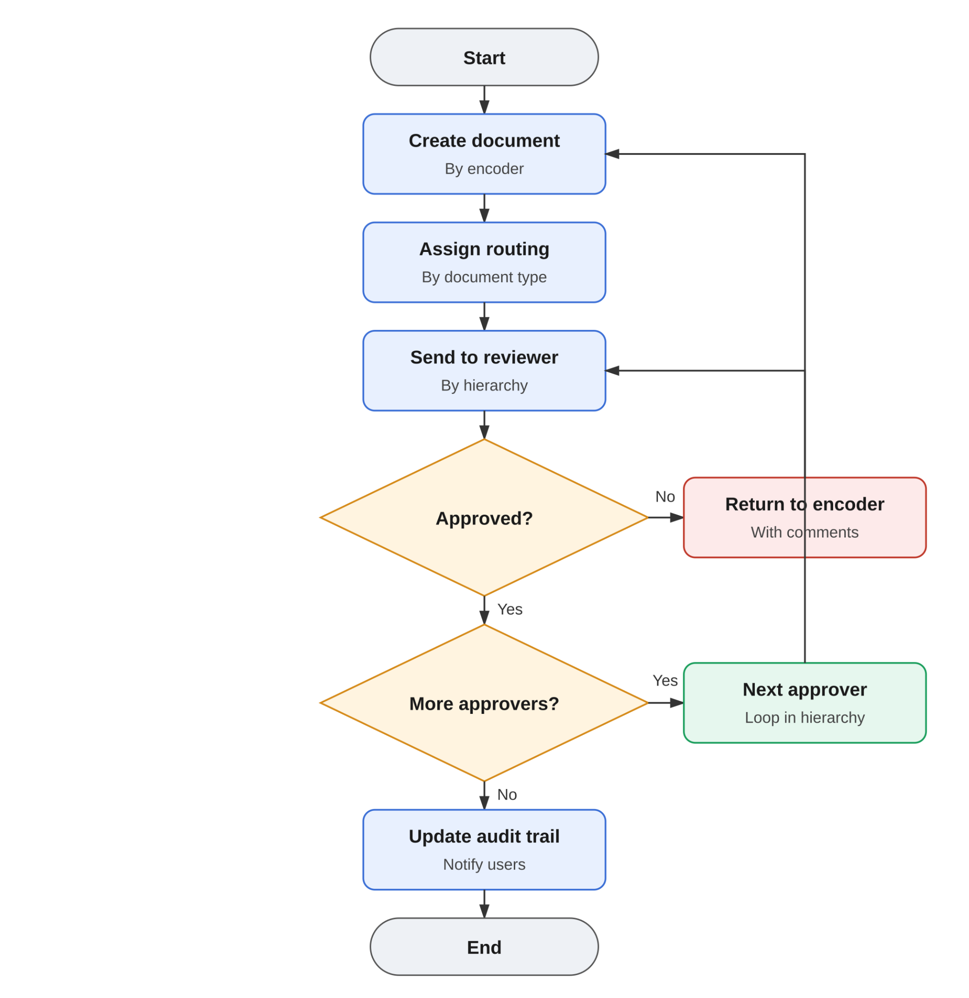
Figure 6. Program Flowchart of Feature #2
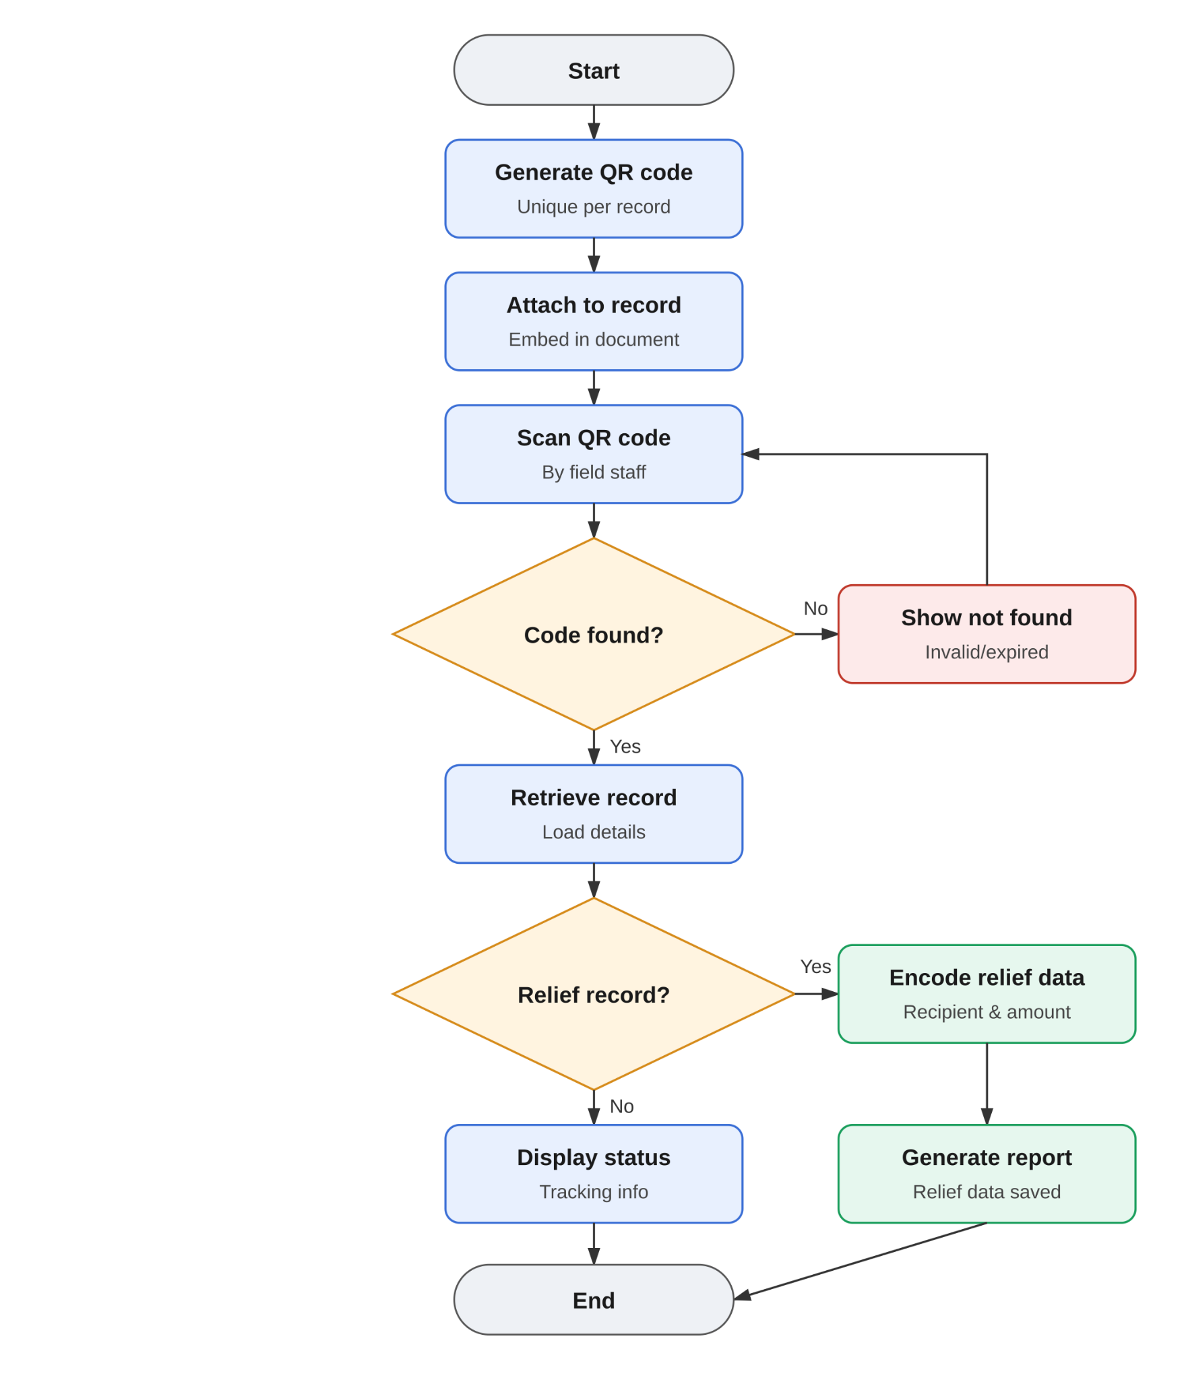
Figure 6 illustrates the system's workflow routing flowchart, mapping the steps a document goes through from creation to approval. The process starts when an encoder completes the create-document task, after which the system immediately assigns routing based on the document type. The file then moves to the Send to Reviewer step, following the organizational hierarchy. A decision point then checks whether the document is approved: a “No” sends it back to the encoder with comments, resetting the process to the creation stage. A “Yes” triggers a follow-up check for additional approvers—if there are more, the process loops through the hierarchy to the next approver and returns the file to the reviewer phase; if there are none left, the system logs the event and notifies users through the update audit trail function before ending at the End node.

Figure 7. Program Flowchart of Feature #3
Figure 7 illustrates how the process begins with creating a unique QR code for every individual record, which is then embedded directly into the relevant document. Once in the field, staff scan the QR code to confirm its validity. If the code turns out to be invalid or expired, the system shows a “not found” error and reroutes the workflow back to the scanning stage; if the code is successfully recognized, the system retrieves the record and loads its details.
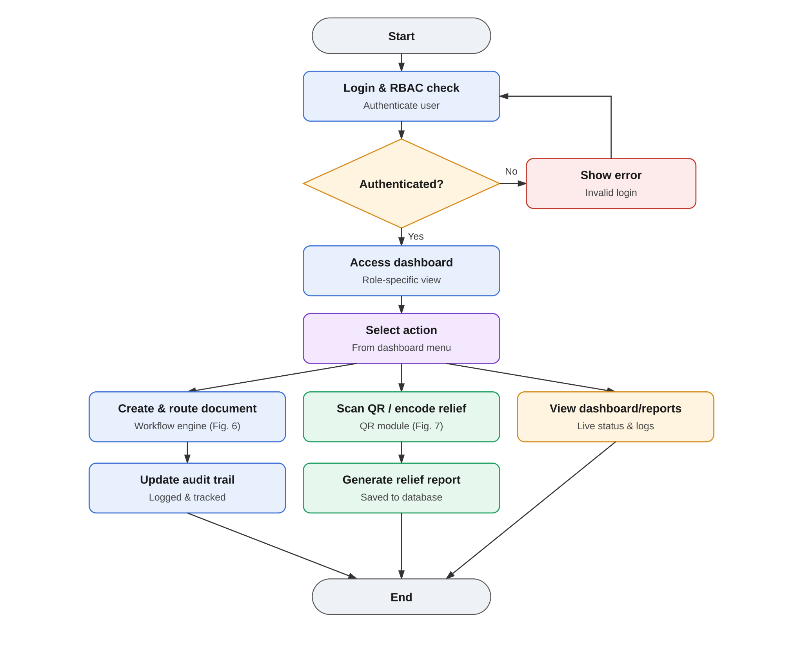
After a successful retrieval, the system checks the record type to determine whether it qualifies as a relief record. If it does, the system encodes the relief data—including the recipient and the amount—and generates a report confirming that the data has been saved before the process ends. If it isn't a relief record, the process simply ends after displaying the general tracking status, skipping the encoding steps altogether.

Figure 8. System Flowchart
Figure 8 illustrates the overarching system flow, which begins by authenticating the user through a Login and RBAC check. If the login attempt fails, the system returns the user to the login phase and displays a “Show error” response; if it succeeds, the user is granted dashboard access with a role-specific view. From there, the user can choose an action from the dashboard menu, which branches into three main workflows:
- Document Management: The workflow engine lets the user create and route documents, which then updates the audit trail so the action is tracked and recorded before moving on.
- QR and Relief Processing: The user can use the QR module to scan or encode relief data, which prompts the system to generate a relief report and save the transaction to the database before moving on.
- Reporting: Alternatively, the user can select View dashboard/reports, which takes them straight to monitoring live status and logs.

System Design and Development Model/Approach
The Integrated Cloud-Enabled Paperless Document Tracking, Workflow Management, and Disaster Relief Distribution Reporting System was developed using the Waterfall Model. This sequential development approach was chosen because it's a natural fit for the DSWD's document processing procedure, which already follows a set, linear sequence from encoding to review to approval. It also meant the requirements gathered at the start of the study directly shaped the database and interface design, which in turn guided the actual coding, before the completed modules were finally tested and integrated as a whole. Each phase was finished and validated before the next one began—a methodical, phase-by-phase progression that let the researchers trace any flaws or design gaps back to a specific stage of development, and helped ensure the final system reflected the DSWD's actual workflow rather than early assumptions.
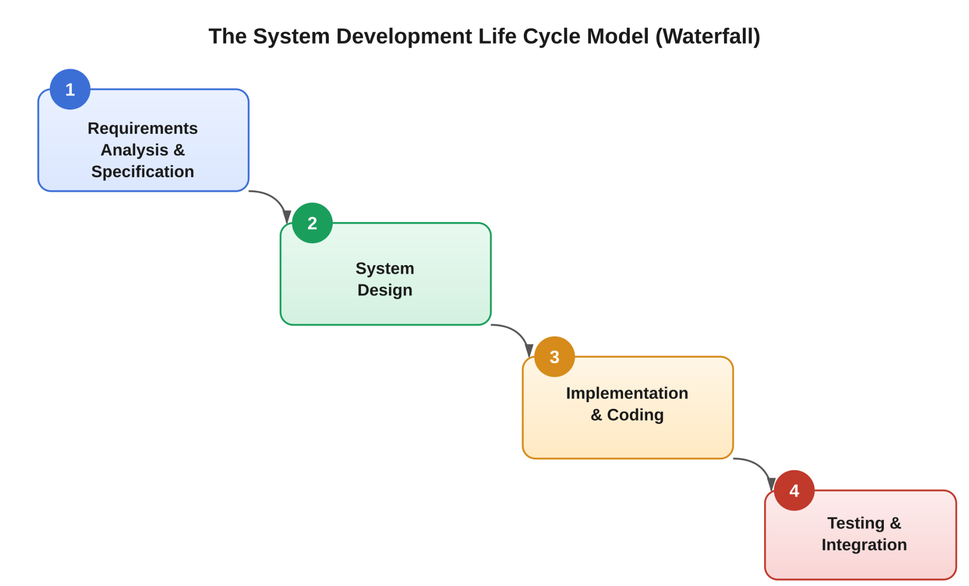
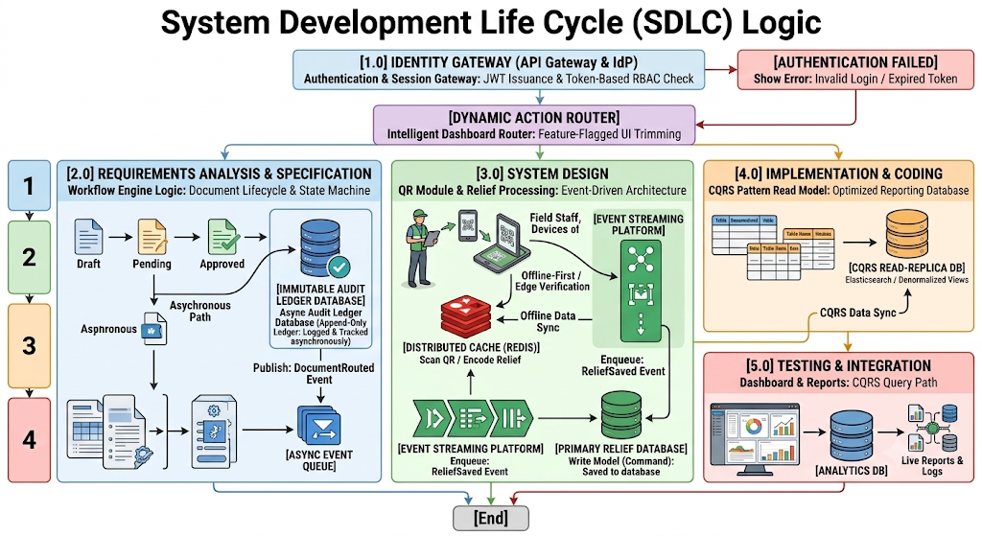
Figure 9. The System Development Life Cycle Model
Figure 9 maps the system's main operational workflows—Identity Management, Dynamic Document States, High-Throughput QR Processing, and the CQRS Read-Model Architecture—across the conventional Waterfall development phases, giving a thorough picture of the System Development Life Cycle (SDLC) logic.
Using the waterfall model, the following are the phases considered to undergo the development process:
- Requirements Analysis and Specification. The researchers gathered all the information and data needed for the proposed system by interviewing organization personnel and observing the processes under study.
- System Design. The engineering blueprint translates structural requirements into decoupled software design patterns, with a strong emphasis on edge verification techniques and asynchronous flow mechanics. Rather than static layout elements, the design uses dynamic dashboard routing—an automated interface router that checks token claims at runtime to fully block unauthorized views. It also incorporates state machine logic, modeling documents through strict, deterministic states: Draft, In Review, and Approved. These state changes trigger isolated asynchronous pathways so that database persistence never locks up or interferes with ongoing user interactions. Finally, the high-throughput QR module is designed around offline-first edge validation, embedding cryptographic record signatures directly inside the QR data matrix and enabling instantaneous cache confirmation through local Redis replicas to keep performance efficient in the field.
- Implementation and Coding. During this phase, the architectural specifications are fully realized through optimized coding frameworks and clear database separations. A core piece of this stage is asynchronous audit logging, implemented through transactional event streaming using tools like SQS or RabbitMQ: whenever a document's state changes, a DocStateTransitioned event publishes downstream to an unchangeable, append-only audit ledger. Relief event streams work the same way, with QR scan events triggering asynchronous queue insertions marked as a ReliefSavedEvent—a design choice that keeps operations non-blocking for field workers by separating scanning execution from the primary database write engine. The write model is also kept isolated to enforce the Command Query Responsibility Segregation (CQRS) pattern, with relational tables highly normalized along this path to ensure fast, single-row writes for all transactional tracking information. single-row writes for all transactional tracking information; and,
- Testing and Integration. This phase runs verification cycles to confirm that all decoupled microservices stay in sync and that analytical read speeds consistently meet user benchmarks. A major focus here is CQRS read path optimization, which thoroughly validates the asynchronous background replication mechanism—such as Elasticsearch or denormalized read replicas—connecting the write database to the query database. Live analytics verification is also carried out to load-test dashboard summary outputs, demonstrating zero lock interference against the operational transactional databases and confirming system stability under heavy load, since log aggregation streams and heavy reporting metrics pull exclusively from the Query Path replica.

Operation and Testing Procedure

In designing, developing, testing, and evaluating the Cloud-Enabled Paperless Document Tracking and Workflow Management with Disaster Relief Distribution Reporting System, the proponents used the ISO/IEC 25010 software quality model, an international standard for evaluating software. It identifies eight criteria: (1) Functional Suitability, (2) Performance Efficiency, (3) Compatibility, (4) Usability, (5) Reliability, (6) Security, (7) Maintainability, and (8) Portability.

The researchers created a testing instrument (see Appendix B), a survey questionnaire based on the ISO/IEC 25010 criteria above, to collect structured feedback from evaluator-respondents on the system's functionality, performance, dependability, and general quality.
To keep the testing process on track, the software was tested to confirm that all of its main modules—the Disaster Relief Distribution Reporting module, the Workflow Automation and Routing Engine, the Real-Time Tracking Dashboard and Audit Trail, the QR Code Generation and Scanning feature, and the Login and RBAC system—operated as intended, with any flaws noted, fixed, and retested before the final assessment with the respondents.

Table 1
Testing Procedure Undertaken by the User-respondents
Module | Test Conducted
Login and RBAC Module | In order to confirm that access was appropriately restricted to their designated permissions, user-respondents logged in using accounts under each role (Encoder, Reviewer, Approver, Administrator).
Workflow Automation and Routing Module | To ensure that every document followed the proper order through the office hierarchy, user-respondents created, routed, and approved sample documents.
Real-Time Tracking Dashboard and Audit Trail | In order to confirm that updates and logged actions appeared in real time, user respondents examined the status of routed documents.
QR Code Generation and Scanning Module | To ensure accurate retrieval, user-respondents created and scanned QR codes on relief records and sample documents.
Disaster Relief Distribution Reporting Module | To ensure accuracy and completeness, user-respondents created reports after encoding sample relief distribution data.
Notification System | User respondents confirmed that they were promptly notified when documents were ready for action.

Table 1 shows the testing procedures undertaken by the user-respondents, listing each module alongside the test conducted on it. This let the researchers confirm that every core function of the system—from authentication down to relief distribution reporting—worked as intended from the perspective of an actual DSWD user, not just the developers.

The proponents also ran their own tests to catch errors, starting with unit testing on each module individually, followed by integration testing once the modules were combined, and tracking every defect found until it was corrected and re-verified—before handing the system over to the user-respondents.
Table 2
Testing Procedure Undertaken by the Proponents
Module | Test Conducted
Login and RBAC Module | Each user type's role-based permission enforcement and authentication logic are unit tested.
Workflow Automation and Routing Module | Integration testing of rejection/return handling, approval sequencing, and routing rules throughout the office hierarchy.
Database | Data storage, retrieval, and document, user, and relief distribution record integrity are tested.
Real-Time Tracking Dashboard and Audit Trail | Verifying that all actions were accurately recorded and that logs could not be changed or removed.
QR Code Generation and Scanning Module | Testing the accuracy of code generation and the dependability of scans on various devices.
Disaster Relief Distribution Reporting Module | Report output is tested against manually validated encoded relief distribution data.
Security | Checking for timeout behavior, session management, and illegal access attempts.

Table 2 shows the testing procedures undertaken by the proponents, listing the system modules and components alongside the functional and integration tests the researchers conducted before releasing the system for user-respondent testing. These validation cycles evaluated both the isolated execution of individual modules and their interaction once fully integrated into the unified system.
These tests were repeated throughout development, with each defect recorded, fixed, and retested to confirm stability, before the system was handed to the user-respondents for the testing process outlined in Table 1.

Evaluation Procedure
To measure the system's performance, a survey based on the ISO/IEC 25010 software quality standard was administered to the identified evaluator-respondents following a live demonstration and hands-on walkthrough of the system's modules. This questionnaire gathered the respondents' ratings and written feedback on the system's functionality, performance, and overall quality, using the five-point scale shown in Table 3.
The following were the steps undertaken by the evaluator-respondents during the evaluation:
- The researchers presented a demonstration on how to operate the software to the group of evaluator-respondents, made up of IT and software quality professionals identified to evaluate the system.
- Evaluator-respondents were then given time to explore and interact with the software.
- Survey questionnaires were distributed to the same group of evaluator-respondents.
- Evaluator-respondents then rated the system's performance on a five-point scale, from 5 (Excellent) down to 1 (Poor).
Table 3
Likert Scale
Numerical Rating | Interpretation
5 | Excellent
4 | Very Good
3 | Good
2 | Fair
1 | Poor
- Data were tabulated to compute the mean of each criteria and the overall mean computation for the six given criteria.
- Results were interpreted using the Rating Scale for interpreting the Evaluation shown in Table 4.
Table 4
Rating Scale for Interpreting the Evaluation Result
Numerical Rating | Interpretation
4.51 - 5.00 | Excellent
3.51 - 4.50 | Very Good
2.51 - 3.50 | Good
1.51 - 2.50 | Fair
1.00 - 1.50 | Poor

Research Instruments Used

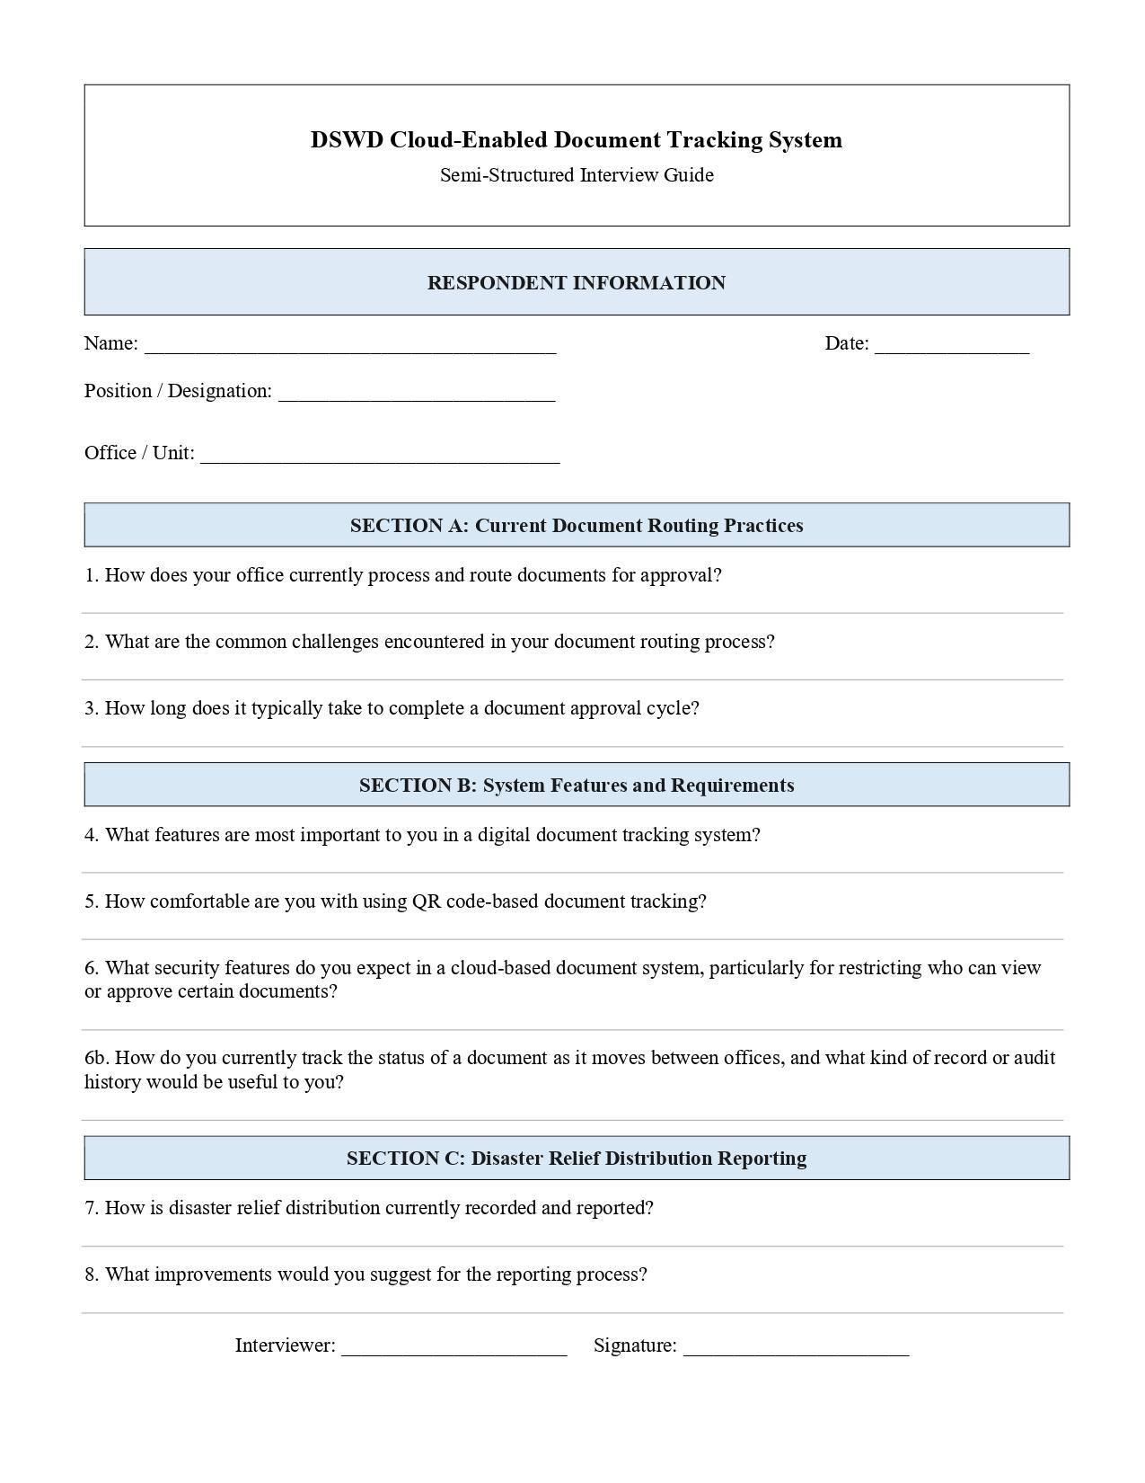
To gather the data needed for this study, the researchers interviewed Abner T. Duarte Jr., an administrative assistant at the Office of the Secretary, DSWD Central Office.

Figure 10. Interview Questionnaire Form Layout
Figure 10 shows the questionnaire answered in an interview conducted on July 16, 2026. It confirmed that the office's document processing was still largely manual, with delays in routing and approval stemming from the lack of a centralized tracking system, and that a QR-based tracking feature paired with role-based access would directly address the challenges raised (see the actual questionnaire in Appendix J).
Once the system was fully developed, respondents were asked to answer one of two survey questionnaires: one for user-respondents, and one for evaluator-respondents using the ISO/IEC 25010 evaluation instrument. Testing and evaluation were then conducted based on the criteria set out in that framework.
The software was tested with the identified user-respondents, who were given hands-on access to its core modules—the Login and RBAC module, the Workflow Automation and Routing Engine, the Real-Time Tracking Dashboard and Audit Trail, the QR Code Generation and Scanning feature, and the Disaster Relief Distribution Reporting module—to confirm each one functioned as intended in an actual working environment before answering the corresponding testing questionnaire (see Appendix A).
The evaluator-respondents, meanwhile, reviewed the system's technical quality against the eight ISO/IEC 25010 characteristics after a live demonstration and hands-on interaction with the system, rating its performance using the evaluation instrument provided (see Appendix B).

Population and Sample

The respondents in this study were DSWD personnel directly involved in document processing and disaster relief distribution at the Office of the Secretary, DSWD Main Office. The population consisted of all personnel in that office who handle document routing, approval, and relief distribution reporting. Using purposive sampling, the researchers selected five user-respondents—encoders, reviewing officers, and approving officers—who tested the system's day-to-day functions (Appendix A), and three evaluator-respondents—IT and software quality professionals—who assessed the system against the ISO/IEC 25010 criteria (Appendix B). Respondents were chosen for their direct involvement in the office's existing document tracking and relief distribution process, making them the most qualified to judge whether the system meets its intended purpose.

Statistical Treatment of Data

The weighted mean was applied to the survey responses to assess the system's degree of acceptability. This statistical tool let the researchers turn the respondents' individual ratings into a single average score per criterion, making it possible to objectively assess the system's performance against each of the eight ISO/IEC 25010 characteristics as well as its overall quality. Microsoft Excel was used to tabulate and compute the quantitative data, consisting of numerical ratings on a five-point scale.
After the questionnaires were collected, a tally sheet was prepared, and the data was recorded, computed, tabulated, and subjected to statistical treatment. To determine the qualitative score, the following formula was used:
Formula:
Weighted Mean = Σ(fx) / N
where:
f = frequency of responses per rating
x = weight assigned to each rating (1–5)
N = total number of respondents

